Title: | Window Lifter  SW Component

History
Issue status  (Index) | Maturity/Date  (draft/invalid/valid)  (dd-mmm-yyyy) | Author  Department | Check/Release  Department | Description
1.0 | Draft  24-0ct-17 | Georgina Salazar | Georgina Salazar | Creation

Table of Contents
1 Purpose 3
2 Definitions and abbreviations 3
3 Realization constraints and targets 3
4 SW Conceptual design 3
5 SW Component internal breakdown 4
5.1 Functional Decomposition 4
5.2 Function <Type> <function name> (type par 1, .., type par n) 5
5.3 Function <Type> <function name> (type par 1, .., type par n) 5

Purpose
This document is intended to document the conceptual design of the requirements and behavior that the window lifter module should have. This is the module responsible to control the window movement.

For this project we use layered programming, this will help us to have a better structure in the code and we can be able to see where we are developing, where this modifications will impact and in the case of error, where is it happening. This project work whit 3 layers, MAL, HAL and APP.

The component that satisfies this project are in the following lists that belong to each layer:

- MAL:
  - WATCH DOG
  - 8MHZ CLOCK
  - 160MHZ CLOCK
  - 80MHZ CLOCK
  - PORT A
  - PORT B
  - PORT C
  - PORT D
  - PORT E
  - PIN E0 (input)
  - PIN E9 (input)
  - PIN C5 (input)
  - PIN B15 (output)
  - PIN B16(output)
  - PIN C14(output)
  - PIN C3(output)
  - PIN E16(output)
  - PIN E15(output)
  - PIN E14(output)
  - PIN E13(output)
  - PIN E1(output)
  - PIN D7(output)
  - PIN D6(output)
  - PIN C15(output)

- HAL:
  - Three buttons, one for up movement, one for down movement and one that represents the anti -pinch signal.
  - One 10 LED red bar, which serves to represent the state of the window, open, closed or partially open.
  - Set the window in closed.
    - The 10 red LEDS in the LED bar are on.
  - Two LEDS to indicate that the button is working, one green for the down button and one blue for the up button.
  - S32K144 device.

- APP:

  - Validated the buttons.
    - One button for down movement, it is validated after a 10 ms press.
    - One button for up movement, it is validated after a 10 ms press.

  - Indicated that the button is in operation.
    - When the up button is pressed, a Blue LED turns on.
    - When the down button is pressed, a Green LED turns on

.
  - Simulated to open the window.
    - If the down button is pressed less than 500 ms the window will open automatically.
    - If the down button is pressed longer than 500 ms the window will open while the Down button is pressed.
    - If the down button is pressed longer than 500 ms the window will open but if the button is released the movement will stop.

  - Simulated to close the window.
    - If the up button is pressed less than 500 ms the window will closed automatically.
    - If the up button is pressed longer than 500 ms the window will closed while the up button is pressed.
    - If the up button is pressed longer than 500 ms the window will closed but if the button is released the movement will stop.

  - Anti-Pinch function.
    - Validated the button after a 10 ms press.
    - Validated the button only when the window is closing.
    - When the anti-pinch signal is detected, the window will change its move and star opening.
    - Once the window is totally open the window has to wait 5s before detecting another button.

Definitions and abbreviations
Definitions
S32K144 |  | Microcontroller Unit
MAL  HAL |  | Microcontroller Abstraction layer  Hardware Abstraction layer
APP  LED |  | Application layer  Light emitting diode
T_ULONG |  | Unsigned long.
T_UBYTE |  | Unsigned char
WDOG |  | Watch Dog
GPIO |  | General Purpose Input and Output
REG |  | Register
ADDR |  | Address
PCC |  | Peripheral Clock Controller
SCG |  | System Clock Generator
LPIT |  | Low Power Interrupt Timer
DISABLE_WDOG |  | Disable Watch Dog
SOSC_INIT_8MHZ |  | Initialize 8 MHZ Clock
SPLL_INIT_160MHZ |  | Initialize 160 MHZ Clock
NORMAL_RUN_MODE_80MHZ |  | Initialize 80 MHZ Clock
LPIT0_INIT | Initialize Low Power Interrupt Timer
PORT_INIT | Initialize Ports
BAR_ON | Set the LED bar on
BAR_CTRL | Control the LED bar

Abbreviations
Only SW Component specific abbreviations.
References
N° | Document name | Reference
1 | V_Cycle Process Script.xlsx
2 | Traceability Matrix Template.xlsx
3 | S32K14x Series Cookbook | https://www.nxp.com
4  5 | S32K144 EVB  S32K1xx Series Reference Manual | https://www.nxp.com  https://www.nxp.com
6 | Window Lifter Requerements.docx

Realization constraints and targets

With this project the window simulate the movement of going up and down. It should have 2 buttons that will help simulate the direction of the movement in a 10 LED bar and 1 extra button for the anti-pinch signal, this will allow only 7 valid button combinations:

- Push up button.
- Push down button.
- Push up button and while it is pressed push down button, the movement shouldn’t change.
- Push down button and while it is pressed push up button, the movement shouldn’t change.
- Push up button and star one touch function then push down button, the movement should stop.
- Push down button and star one touch function then push up button, the movement should stop.
- Push anti -pinch button during up movement, the movement should change until the window is totally open.

Every button must be validated when is pressed, that means that each button should be pressed at less 10 ms before it star to work.If the press is valid for down a green LED turn on and if the press is valid for up a blue LED turn on.
The led bar for the window simulation shall be red.

The window need a constant push in the up or down button for the press function.

After an anti –pinch signal is detected the window has to open and the system will stand by for 5 s.

SW Conceptual design

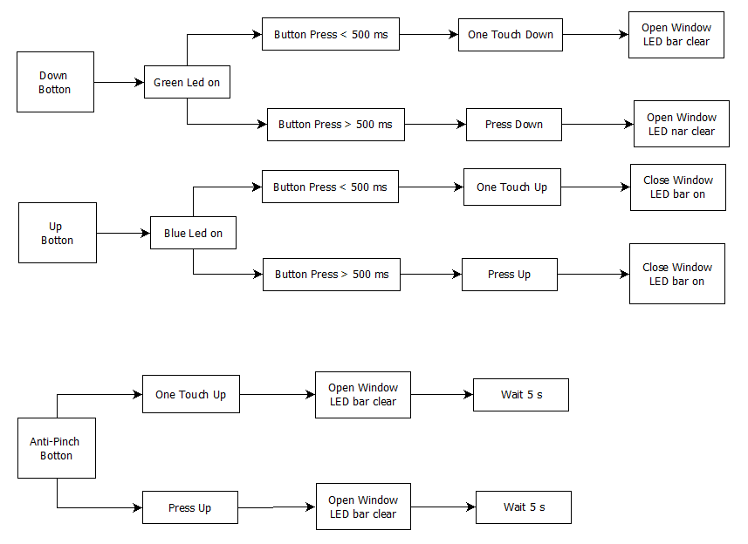
The functional architecture for the window lifter is as follow:

The physical architecture for the window lifter includes layer MAL, layer HAL and layer APP, the following block diagram show his behavior:

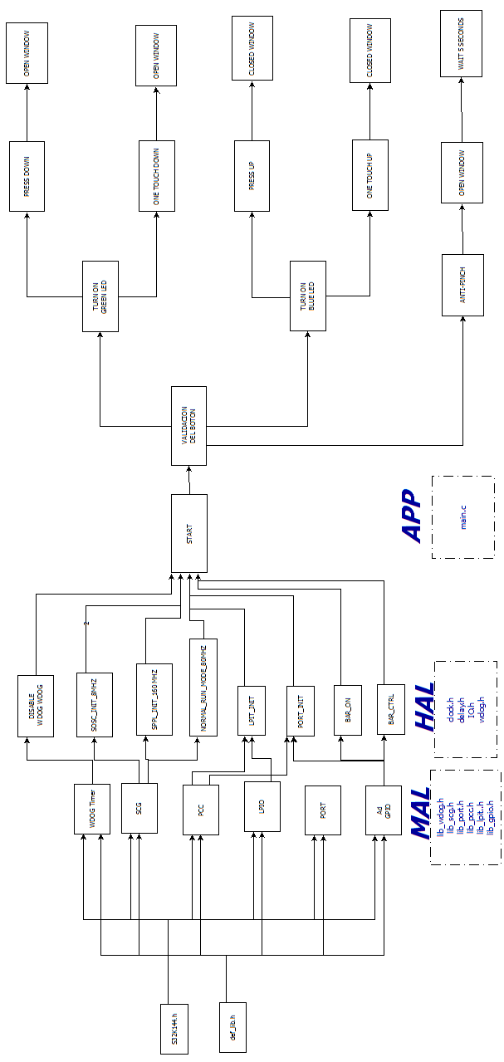

SW Component internal breakdown

The window lifter will work in a similar way to a state machine:

State 0: Validate the buttons.

State 1: Turn on the green LED (Down).

State 2: Open the window while the button is press.

State 3: Turn on the green LED (Down).

State 4: Close the window while the button is press.

State 5: Open the window automatically.

State 6: Close the window automatically.

State 7: Anti-Pinch function.

State 8: The window wait 5s before continue.

State 9: Stop the automatically down movement.

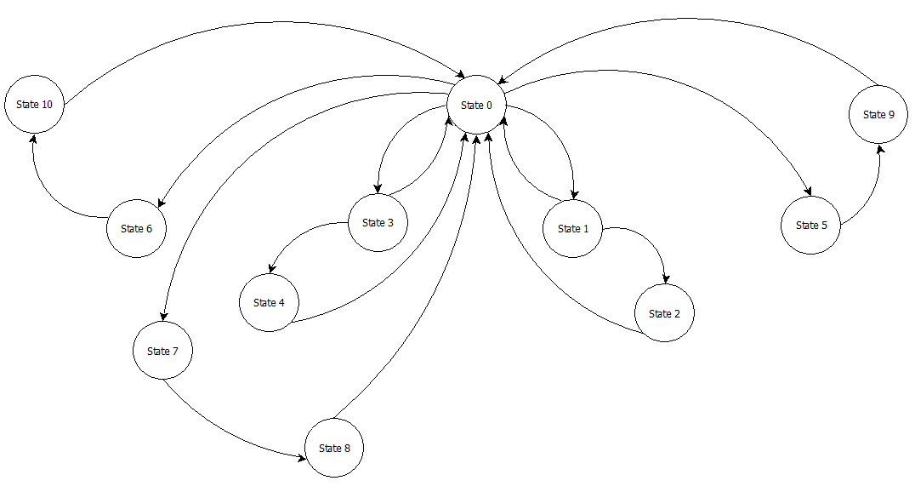
State 10: Stop the automatically up movement

Functional Decomposition

In this section will be include the detailed static and dynamic description of all functions of the Window Lifter Component.

Function void WL_INIT ()

Description | This function is the responsible to initialize the ports.
Parameter 1  <input| output| input> | The function should enable the port and set them as inputs and outputs.
Parameter 2..n
Return Value | void
Precondition | Include the windowlifter.h library.
Post condition | main.c calls the function to be able to use the ports.
Error Conditions

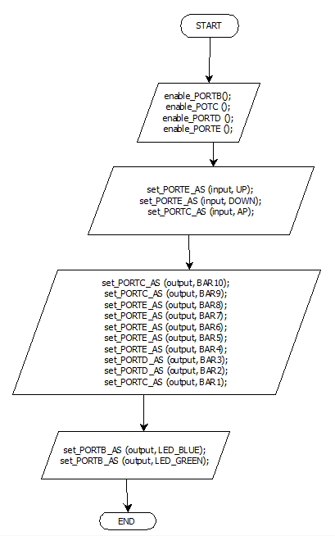

Function void BAR_ON ()

Description | This function is the responsible to turn on the LED bar .
Parameter 1  <input| output| input> | The function set the pins that correspond to each led of the bar.
Parameter 2..n
Return Value | void
Precondition | Include the windowlifter.h library.
Post condition | main.c calls the function to be able to simulate a close window at the begging.
Error Conditions
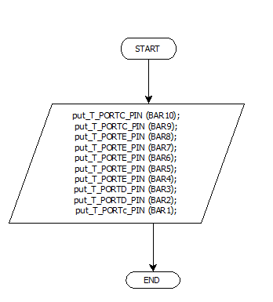

Function void BAR_CTRL (T_UBYTE t_uLed)

Description | This function controls the turning on and turning off of the leds.
Parameter 1  <input| output| input> | The function evaluates pin per pin to see that it is corresponding to the pressure.
Parameter 2..n
Return Value | void
Precondition | Include the windowlifter.h library.
Post condition | main.c calls the function each time it detect the pressure on a button.
Error Conditions

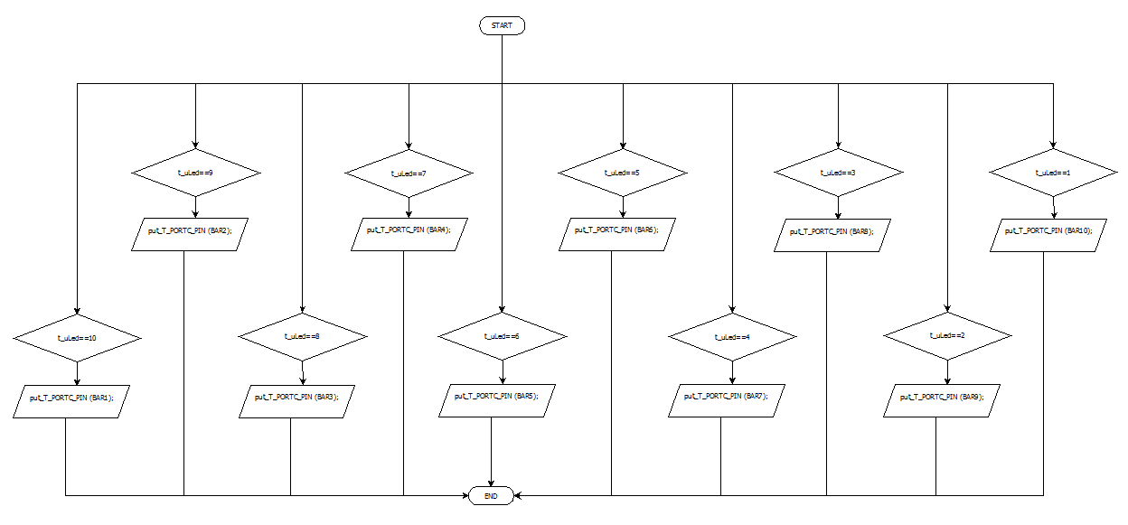

Function void LED_BLUE_ON ()

Description | This function turn on the blue LED.
Parameter 1  <input| output| input> | The function send a high signal to the blue LED pin.
Parameter 2..n
Return Value | void
Precondition | Include the windowlifter.h library.
Post condition | main.c calls the function every time the up button is pressed.
Error Conditions

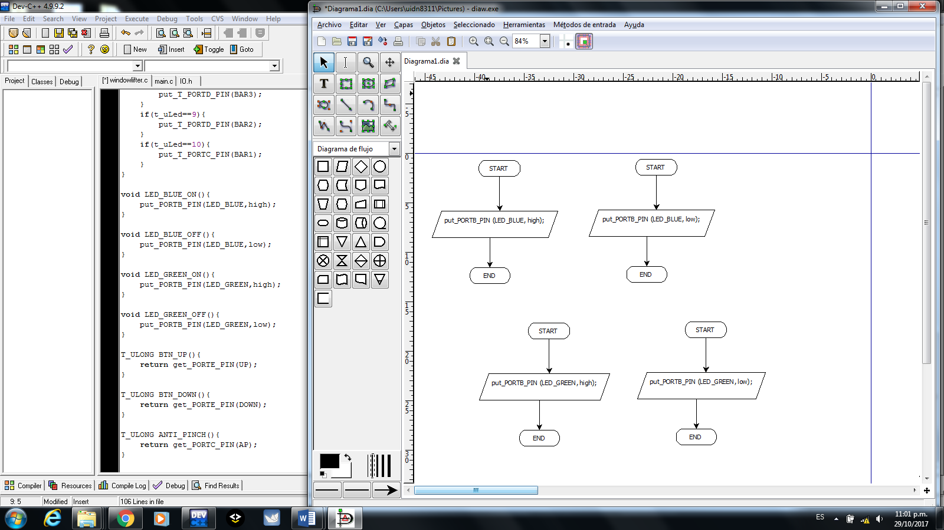

Function void LED_BLUE_OFF ()

Description | This function turn off the blue LED.
Parameter 1  <input| output| input> | The function send a low signal to the blue LED pin.
Parameter 2..n
Return Value | void
Precondition | Include the windowlifter.h library.
Post condition | main.c calls the function every time the up button is release.
Error Conditions

Function void LED_GREEN_ON ()

Description | This function turn on the green LED.
Parameter 1  <input| output| inout> | The function send a high signal to the green LED pin.
Parameter 2..n
Return Value | void
Precondition | Include the windowlifter.h library.
Post condition | main.c calls the function every time the down button is pressed.
Error Conditions

Function void LED_GREEN_OFF ()

Description | This function turn off the green LED.
Parameter 1  <input| output| input> | The function send a low signal to the green LED pin.
Parameter 2..n
Return Value | void
Precondition | Include the windowlifter.h library.
Post condition | main.c calls the function every time the down button is release.
Error Conditions

Function T_ULONG BTN_UP ()

Description | This function is the responsible to validate the up button.
Parameter 1  <input| output| input> | The function check that the input signal is long enough.
Parameter 2..n
Return Value | T_ULONG
Precondition | Include the windowlifter.h library.
Post condition | main.c calls the function before star closing the window.
Error Conditions
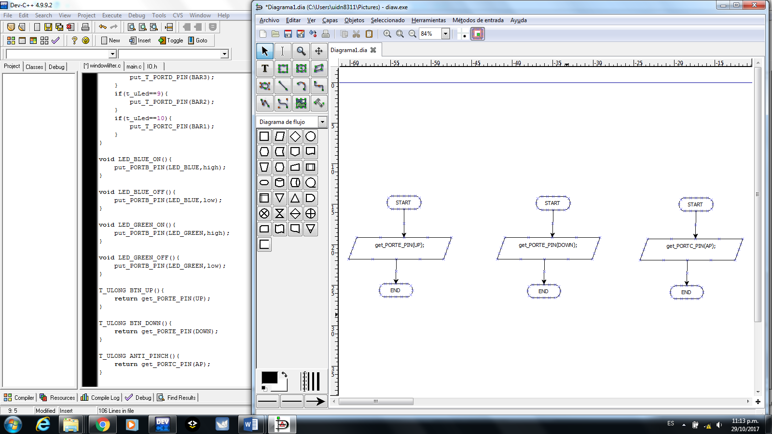

Function T_ULONG BTN_DOWN ()
Description | This function is the responsible to validate the down button.
Parameter 1  <input| output| input> | The function check that the input signal is long enough.
Parameter 2..n
Return Value | T_ULONG
Precondition | Include the windowlifter.h library.
Post condition | main.c calls the function before star opening the window.
Error Conditions

Function T_ULONG ANTI_PINCH ()

Description | This function is the responsible to validate the anti-pinch button.
Parameter 1  <input| output| input> | The function check that the input signal is long enough.
Parameter 2..n
Return Value | T_ULONG
Precondition | Include the windowlifter.h library.
Post condition | main.c calls the function before star executing the anti-pinch function.
Error Conditions

Function void DISABLE_WDOG ()

Description | This function is the responsible of turning off the watch dog in the microcontroller.
Parameter 1  <input| output| inout> | Unlock watchdog
Parameter 2..n
Return Value | void
Precondition | The Watch Dog timer need to be mapped in the MAL layer before it can be implemented in a function for the HAL layer, the APP layer just called it at the begging of the execution.
Post condition | The APP layer execute with the watch Dog disabled.
Error Conditions

Function void config_XTAL ()
Description | Enable external crystal oscillator
Parameter 1  <input| output| inout> | The function set a medium frequency and ensure the signal is unlocked.
Parameter 2..n
Return Value | void
Precondition | The signal need to be mapped in the MAL layer before it can be implemented in a function for the HAL layer, the APP layer just called it at the begging of the execution.
Post condition | A stable clock signal is set for the APP layer
Error Conditions

Function void set_delay_us (T_ULONG t_uTime)
Description | This function generate a delay of 1 microsecond.
Parameter 1  <input| output| inout> | Check how many seconds the user needs.
Parameter 2..n
Return Value | void
Precondition | The signal need to be mapped in the MAL layer before it can be implemented in a function for the HAL layer, the APP layer just called it at the begging of the execution.
Post condition | The system works with the chosen delay.
Error Conditions

Function void set_delay_ms (T_ULONG t_uTime)
Description | This function generate a delay of 1 milisecond.
Parameter 1  <input| output| inout> | Check how many seconds the user needs.
Parameter 2..n
Return Value | void
Precondition | The signal need to be mapped in the MAL layer before it can be implemented in a function for the HAL layer, the APP layer just called it at the begging of the execution.
Post condition | The system works with the chosen delay.
Error Conditions

Function void set_delay_s (T_ULONG t_uTime)
Description | This function generate a delay of 1 second.
Parameter 1  <input| output| inout> | Check how many seconds the user needs.
Parameter 2..n
Return Value | void
Precondition | The signal need to be mapped in the MAL layer before it can be implemented in a function for the HAL layer, the APP layer just called it at the begging of the execution.
Post condition | The system works with the chosen delay.
Error Conditions

Function void delay_start (void)
Description | This function enable the LPTI counter.
Parameter 1
<input| output| inout>
Parameter 2..n
Return Value | void
Precondition | The signal need to be mapped in the MAL layer before it can be implemented in a function for the HAL layer, the APP layer just called it at the begging of the execution.
Post condition | Once the LPTI ends, it re start the values.
Error Conditions

Function void enable_PORTB ()
Description | Enable the port clock to the port B.
Parameter 1
<input| output| inout>
Parameter 2..n
Return Value | void
Precondition | The signal need to be mapped in the MAL layer before it can be implemented in a function for the HAL layer, the APP layer just called it at the begging of the execution.
Post condition | Enable the port clock controller.
Error Conditions

Function void enable_PORTC ()
Description | Enable the port clock to the port C.
Parameter 1
<input| output| inout>
Parameter 2..n
Return Value | void
Precondition | The signal need to be mapped in the MAL layer before it can be implemented in a function for the HAL layer, the APP layer just called it at the begging of the execution.
Post condition | Enable the port clock controller.
Error Conditions

Function void enable_PORTD ()
Description | Enable the port clock to the port D.
Parameter 1
<input| output| inout>
Parameter 2..n
Return Value | void
Precondition | The signal need to be mapped in the MAL layer before it can be implemented in a function for the HAL layer, the APP layer just called it at the begging of the execution.
Post condition | Enable the port clock controller.
Error Conditions

Function void enable_PORTE ()
Description | Enable the port clock to the port E.
Parameter 1
<input| output| inout>
Parameter 2..n
Return Value | void
Precondition | The signal need to be mapped in the MAL layer before it can be implemented in a function for the HAL layer, the APP layer just called it at the begging of the execution.
Post condition | Enable the port clock controller.
Error Conditions

Function void set_PORTB_AS (T_ULONG LVL,T_ULONG PIN)
Description | Set the port as an input.
Parameter 1  <input| output| inout> | T_ULONG LVL,T_ULONG PIN
Parameter 2..n
Return Value | void
Precondition | The signal need to be mapped in the MAL layer before it can be implemented in a function for the HAL layer, the APP layer just called it at the begging of the execution.
Post condition | The port B is set as an input.
Error Conditions

Function void set_PORTC_AS (T_ULONG LVL,T_ULONG PIN)
Description | Set the port as an input.
Parameter 1  <input| output| inout> | T_ULONG LVL,T_ULONG PIN
Parameter 2..n
Return Value | void
Precondition | The signal need to be mapped in the MAL layer before it can be implemented in a function for the HAL layer, the APP layer just called it at the begging of the execution.
Post condition | The port C is set as an input.
Error Conditions

Function void set_PORTD_AS (T_ULONG LVL,T_ULONG PIN)
Description | Set the port as an input.
Parameter 1  <input| output| inout> | T_ULONG LVL,T_ULONG PIN
Parameter 2..n
Return Value | void
Precondition | The signal need to be mapped in the MAL layer before it can be implemented in a function for the HAL layer, the APP layer just called it at the begging of the execution.
Post condition | The port D is set as an input.
Error Conditions

Function void set_PORTE_AS (T_ULONG LVL,T_ULONG PIN)
Description | Set the port as an input.
Parameter 1  <input| output| inout> | T_ULONG LVL,T_ULONG PIN
Parameter 2..n
Return Value | void
Precondition | The signal need to be mapped in the MAL layer before it can be implemented in a function for the HAL layer, the APP layer just called it at the begging of the execution.
Post condition | The port E is set as an input.
Error Conditions

Function T_ULONG get_PORTB_PIN(T_ULONG PIN)
Description | The function gets the value of the pin.
Parameter 1  <input| output| inout> | T_ULONG LVL,T_ULONG PIN
Parameter 2..n
Return Value | void
Precondition | It has to be enable as an input
Post condition | The pins of the port B are enable as inputs.
Error Conditions

Function T_ULONG get_PORTC_PIN(T_ULONG PIN)
Description | The function gets the value of the pin.
Parameter 1  <input| output| inout> | T_ULONG LVL,T_ULONG PIN
Parameter 2..n
Return Value | void
Precondition | It has to be enable as an input
Post condition | The pins of the port C are enable as inputs.
Error Conditions

Function T_ULONG get_PORTD_PIN(T_ULONG PIN)
Description | The function gets the value of the pin.
Parameter 1  <input| output| inout> | T_ULONG LVL,T_ULONG PIN
Parameter 2..n
Return Value | void
Precondition | It has to be enable as an input
Post condition | The pins of the port D are enable as inputs.
Error Conditions

Function T_ULONG get_PORTE_PIN(T_ULONG PIN)
Description | The function gets the value of the pin.
Parameter 1  <input| output| inout> | T_ULONG LVL,T_ULONG PIN
Parameter 2..n
Return Value | void
Precondition | It has to be enable as an input
Post condition | The pins of the port E are enable as inputs.
Error Conditions

Function T_ULONG get_PORTB_PIN(T_ULONG PIN)
Description | The function gets the value of the pin.
Parameter 1  <input| output| inout> | T_ULONG LVL,T_ULONG PIN
Parameter 2..n
Return Value | void
Precondition | It has to be enable as an input
Post condition | The pins of the port B are enable as inputs.
Error Conditions

